https://www.jdoodle.com/embed/v0/5TUU

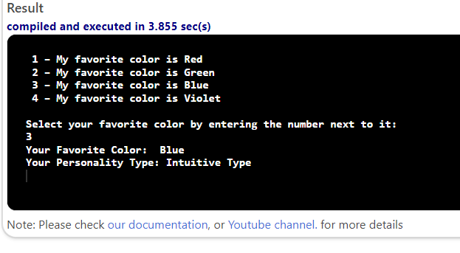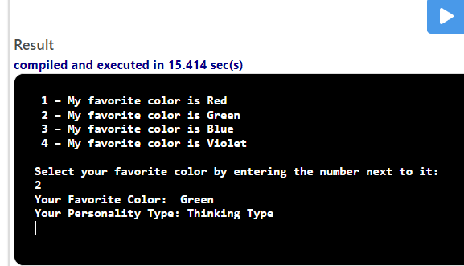

#include <iostream>

using namespace std;

int main()
{
int option;
string menu = "";
menu = menu + " 1 – My favorite color is Red \n";
menu = menu + " 2 – My favorite color is Green \n";
menu = menu + " 3 – My favorite color is Blue \n";
menu = menu + " 4 – My favorite color is Violet \n";
menu = menu + " \n";
menu = menu + "Select your favorite color by entering the number next to it:\n";
cout << menu;
cin >> option;
switch (option)
{
case 1:
cout << "Your Favorite Color: Red" << endl;
cout << "Your Personality Type: Feeling Type" << endl;
break;

case 2:
cout << "Your Favorite Color: Green" << endl;
cout << "Your Personality Type: Thinking Type" << endl;
break;

case 3:
cout << "Your Favorite Color: Blue" << endl;
cout << "Your Personality Type: Intuitive Type" << endl;
break;

case 4:
cout << "Your Favorite Color: Green" << endl;
cout << "Your Personality Type: Sensing Type" << endl;
break;
default:
cout << "Invalid Input" << endl;
break;
}
return 0;
}

